Amrita Vishwa Vidyapeetham

Amrita School of Engineering

Department of Mechanical Engineering

19MEE100 Engineering Drawing CAD I

**Sketch Notebook Assignment No. 2 Projection of Points**

1. Draw the projections of the following points. Take the distance between the projectors as 25 mm.
2. Point A is 20 mm above HP and 42 mm in front of VP
3. Point B is 35 mm below HP and 20 mm in front of VP
4. Point C is 20 mm above HP and 36 mm behind VP
5. Point D is 42 mm below HP and 25 mm behind VP
6. The orthographic projections of certain points are shown in fig. Determine their positions with respect to the reference planes and interpret them.

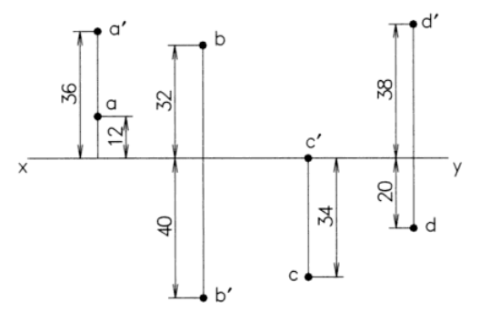

1. A point L is located 30 mm below HP and 36 mm behind VP. Draw the projections of point L.
2. Point E is located in the third quadrant. The distance from HP is 32 mm and that from VP is 26 mm. Draw the projections of the points on HP and VP.
3. A point P is on HP and 20 mm in front of VP. Another point Q is also on HP and behind VP. The distance between their end projectors is 60 mm. Draw its projections if the line joining P and Q makes an angle of 600 with reference line. Also find the position of point Q.
4. The points A and B are in the HP. The point A is 30 mm in front of VP. The distance between their projectors is 70 mm and the line joining their plans makes an angle of 30 degree with XY. Find the distance of the point B from the VP.
5. Point F is located in the second quadrant. The distances from HP and VP are 38 mm and 28 mm respectively. Similarly, point G is located in the fourth quadrant. The distances from HP and VP are 40 mm and 25 mm respectively. Draw the projections of the points on HP and VP.
6. A point 30 below xy is the plan view of 2 points P & Q. Elevation of P is 40 above HP while that of Q is 30 below HP. Draw the projections and state their positions and Quadrants.
7. P is 15mm below HP & 20mm behind VP. Q is 40mm above HP and 25 in front of VP. The distance between their projectors is 90 mm. Draw lines joining their (i) top views. (ii) Their front views.
8. Draw the projections of the following points on a common xy – line. Take the distance between the projectors as 50 mm.
9. Point A, 20 mm above HP and 30 mm behind VP
10. Point B, 15 mm below HP and 40 mm in front of VP.

***********************

Note:

1. This assignment to be drawn in sketch note book
2. Dead line: 20-Aug-2019
3. Use thick and thin line at appropriate places
4. Dimension as per standards.